**Mini Project: Unit 5**

In this Mini Project, we will analyze the difference frictionless trading and trading in real life. Most of the data published in popular media on the return profiles of trading systems consider frictionless trading – an ideal universe where there is no slippage, no commissions, trading costs and gaps. As we will see in this Project, real life is much tougher.

1. Write a Python program to download the historical data of Dow Jones Industrial Average (DJIA) over the last 15 years.

**I downloaded the historical data of Dow Jones Industrial Average (DJIA) over the last 15 years from Yahoo Finance.**

**def __download_data(self):**

**self.__index_data = pdr.get_data_yahoo(self.__index,**

**self.__start_date,**

**self.__end_date)**

1. Construct a simple trading system that goes long when DJIA closes above its 20 Day Exponential Moving Average of Close Prices (20 DEMA) and closes in position and goes short when prices close below the 20 DEMA.
2. Exit from Trades are made by stop Market orders at the price of the 20 DEMA. Start with 10,000$ and always invest 1,000$ in every single trade
3. **Case 1:** Consider frictionless trading
   1. Consider that you are able to enter into trades exactly at the close price of the day on which the trend starts
   2. Consider ideal fills exactly on entry and stop loss exits on the 20DEMA.
   3. No Slippage or brokerage or commissions to be taken into account – consider you are trading for free!
   4. Plot the return profile of such a trading system.

**I implemented a strategy when I enter a trade at the close price and exit a trade with the 20DEMA price.**

1. **Case 2:** Consider Real Trading
   1. **Gaps**: Enter trades at Market Open the next day through Stop Limit Orders – this is the way traders have to do things in real life (hence exposed to opening gaps)
   2. **Brokerage & Commissions:** Check the Interactive brokers site and decide on a Brokerage ratio to use for your trades
   3. **Slippage:** Use the model generated in Unit 5 Assignment to consider slippages on each and every trade.
   4. Graphically represent the return profile of this strategy
2. Compare the Risk-Return Profiles of both the systems and draw inferences

**I implemented a strategy when considered gaps, commission and slippage. I put broker commission equal to 0.08% and used the model from Assignment 5 for the slippage price.**

**Slippage_Price = Current_Price + 0.08 * (Close_Price – Open_Price) + 0.02 * (High_Price – Low_Price)**

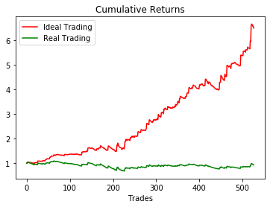

**We can see that real trading significantly differs from trading in ideal conditions. In our case we not only made less money, moreover, we lost money in the observed period.**